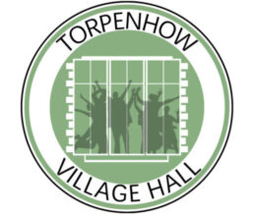

TORPENHOW VILLAGE HALL FACT SHEET

HIRE CHARGES:
Please contact: torphallbookings@gmail.com 0778 703 8859 for our hire charges.
The length of hire should include setting up and clearing away times.
The rates include use of kitchen and the contents, (crockery, glasses etc), as well as Wi-Fi and music system if required. The hall can accommodate 120 people .
BAR : The hall is fully licensed and the committee can provide a bar for events if required
MAIN HALL:
17m x 9m including a portable stage 6m x 3m x 6m (Max height for screens or structures = 4m)
100 stacking chairs. 24 folding chairs
7 banqueting tables (6ft x 2.5ft, which are higher than the other tables and suitable for wheelchair users).
16 large tables (5ft x 2.5ft)
8 small tables (3ft x 2.5ft)
Fixed projector screen 3m x 3m, (a PC projector is available for hire)
KITCHEN :
Large oven / hob range cooker, Fridge , Dishwasher , Microwave
Crockery, glassware and cutlery available for 100 people
To book or enquire further please contact :
Email : torphallbookings@gmail or phone 0778 703 8859
Visit our website : https://torpenhowvillagehall.org.uk

